Barriers to Cycling

**What is the purpose/audience for this doc?**

There are many perceived and real barriers to cycling. It is important to ensure that these are mitigated through physical infrastructure and social norms. Look out for opportunities to ensure these barriers aren’t being perpetuated or entrenched in your buildings, streets, conversations, communities.

**Perception of Danger**

A major contributor to this disinformation and fear-mongering in the media. Many of those who rely on automobiles in our cities feel threatened by the rise in interest in cycling and as a result they try to deter people from cycling by playing up the inherent dangers of cycling.

Cycling with good lighting is also an important factor especially for female cyclists. If a place is dark with poor passive surveillance, then females will be very reluctant to ride, no matter how good the infrastructure. For this reason it is important that prominent pedestrian and cycling infrastructure be collocated with other well utilised mobility routes and active streetscapes rather than relegated to back blocks.

Example:

Sarah played soccer at Albert Park and would ride home to Footscray after training Tuesday and Thursday nights between 9 - 10pm. The trail from docklands is a relatively high quality trail and well lit but the lack of other riders, pedestrians or easily reachable car users made it a bit of a scary ride when there were only a few, and always men, out at that time. It was at the time that Jill Meagher went missing and the rhetoric is still the same, why was she out at that time, in that location, alone.

***Even if the danger is minute, it is essential that infrastructure be safe and FEEL safe!***

**Social/Cultural Barriers**

Social norms governing behaviour have favoured motorised travel over active transport since WW2, even for journeys short enough to be completed by bicycle. How many media campaigns exist around car purchase and use?

The social and cultural norms and momentum associated with driving is enormous and exceedingly difficult to overcome.

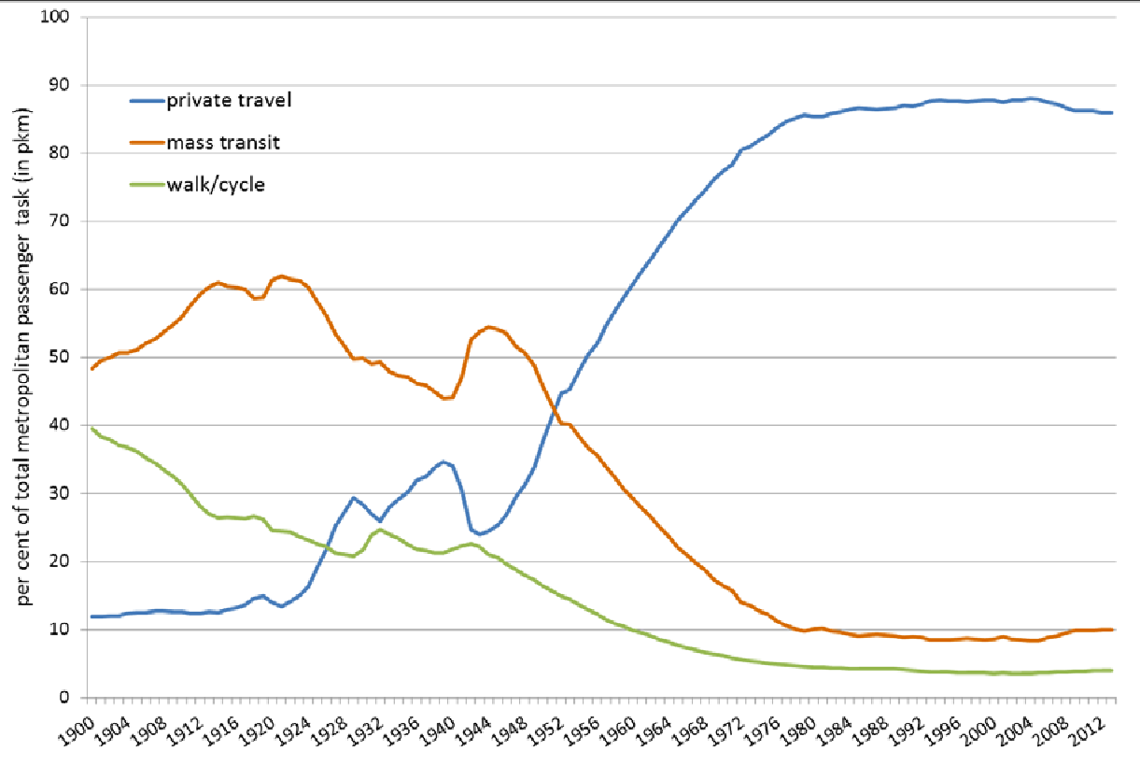

**Policy and regulatory barriers**

Public health is affected by a range of factors not generally considered related to the health sector. Transport and land use policies have an enormous impact on public health, in either a positive or negative direction. A review of the evidence supporting cycling by the National Institute for Health and Clinical Excellence in the UK recommended that ‘Transport policies should be subject to more systematic use of health impact assessments’ (Killoran et al, 2006, p. 5). It is essential that such health impact assessments be conducted on all transport projects. The assessment would include impacts on road safety, noise and air pollution, liveability, and sedentary lifestyle disease. However, even mentioning this to traffic engineers is seen as heresy.

**Legal**

In many European countries, the assumption of guilt in road traffic accidents lies with the driver of the motor vehicle. Not in Australia. Eg if a cyclist is travelling along a road and a motorist overtakes the cyclist and immediately turns left in front of the cyclist and knocks them over, from a legal point of view, this is considered the cyclist’s fault. As the motorist arrived at the intersection first, they therefore have right of way. In reality of course, the opposite is true.

**Theft**

Bicycle theft creates a barrier to cycling that can’t be ignored. It is necessary to advocate for sufficient (in quantity and security) bike parking spaces and cages at locations where people need to leave or store their bicycles. This includes at private houses and apartments, at train stations and other public transport hubs, at office / work locations, and at schools, sport and recreation venues, and at shops, libraries and other civic and cultural venues.

**Multitasking/Proper equipment**

Even if someone is able to overcome the initial apprehension, finding the right bike can be another big obstacle primarily affecting women. We’ve heard from women who were expected to ride a bike that was initially bought for a child or something picked up from a garage sale that was simply way too heavy for them.

Although the debate about women’s bikes rages on, it is important to understand that, in general, women do have different anatomy and for some, it can make a huge difference. Especially when starting out, it is so important to have a bike that makes you feel comfortable and supported. For that reason – it may be necessary to try out many different models and adjustments to get the right fit, and that is OK.

Many people think they will get a cheap bike and then when they prove to themselves that they will use it enough they will be able to justify spending a bit more money on a better bike. The problem with this logic is that the ‘cheap’/second hand bike is poorly designed and fitted and therefore uncomfortable to ride and so doesn’t get used, and thus the ‘better’ bike is never acquired. It is important to ensure your bike is suitable for the style of riding, distances, and conditions you intend to ride in. Consider also the savings you will make by not using a car, public transport, or taxi service. Think about how to invest some of this in your bike selection to avoid wasting money by trying to save money.

**Lack of Community**

Trying something new and unfamiliar, especially as we get older, can be difficult. Women are the minority of bike commuters in most cities and casual women riders are an even smaller demographic. We all know that cycling is more fun with friends and it is important that inclusive and women’s only events continue to garner the traction and visibility they need to keep growing. Thankfully there are more of these events popping up all the time but it is also important that we make an effort to reach out to one another. Whether you’re the one curious about cycling or think you might have a friend who is, don’t be shy to ask. The worst-case scenario is they simply won’t be interested, while alternatively – you might just end up with another cycling pal.

Lots of people remember riding as children but drop off as they get older. It is important to continue to cultivate riding in family and friendship groups when children enter their teenage years. Data shows the single most important influencer in a family is the female caregiver. If the ‘mother’ rides it is more likely others will too. For this reason it is important for women to feel confident riding as they will also largely dictate whether or not they feel confident letting their children ride. Especially as they graduate from riding with the family to riding independently. Encouraging children to ride with their friends also ensures that they do not become dependent on parental chauffeurs. It is important for children's development to build autonomy and agency, being independently mobile is a great opportunity to cultivate these skills.

**Guilt**

It also remains the case that women simply tend to have more demands placed on them at home and in the family. We’ve also heard from women whose partners or family members became jealous or threatened when they took up cycling. Although this inevitably happens to men too, it is still largely the case that women tend to experience less leeway when it comes to being away from the home for extended periods, especially if it is for leisure activity. Although we may all agree that everyone deserves the freedom and time to pursue their hobbies and passions, not every family dynamic is the same. It is necessary that we continue to promote safe spaces for women to ride and find empowerment.

Lots of people and parents are made to feel like they are being irresponsible with regard to their personal or children's safety if they opt to ride bicycles. Unfortunately this is also a phenomenon most acutely experienced by women.

Ultimately, it is about shifting the focus from how we can change women to get them more interested in bikes and rather look at how we can make cycling part of the solution for the challenges women face in their everyday lives. Riding a bike is a beautiful thing, let’s get more people doing it.

**Topography**

In the west we are particularly fortunate to have a relatively flat typography. Even across the vast majority of Melbourne the terrain is quite amenable to cycling especially if the appropriate bike is selected for the distance and conditions being ridden. Many prominent routes follow our locals rivers and train lines which also help ensure they are gentle and pleasant to ride on. In situations where topology (and distance) pose a barrier it is important to ensure bikes have the right gear ratio, or helpful to utilise electric assist technology.

**Fitness/Confidence**

There are many detrimental assumptions about the ‘sort’ of people who cycle and the kinds of people who are excluded from identifying as bike riders. Unfortunately infrastructure and stigma work in tandem to encourage confident and fearless riders. In some cases an abundance of this cohort makes other riders, and other road users, feel unsafe and antagonised.

Poor and insufficient infrastructure fails to adequately delineate space for the huge range of riders that might be using it. Cars and other vehicles travel at largely a uniform speed whereas bike users can vary significantly in the speed at which they can travel. Often there is insufficient space allocated for overtaking and long stretches where moving into the oncoming bike lane puts people in danger of collision. Often it is therefore the slower, more cautious, more courteous, and often female riders who yield to faster more aggressive riders. Where bike lanes are adjacent to vehicle lanes, overtaking is forced into the vehicle lane, putting vulnerable road users into the path of traffic who are expecting them to stick to the lane provided.

Riding with friends and family can be a great way to encourage and normalise riding, and can make it more enjoyable at any age and stage. There are almost no places where it is possible to ride 2 abreast without drawing the ire of other rivers, pedestrians, or road users. This is to the significant detriment of cultivating an atmosphere of camaraderie and enjoyment. Walking side by side or talking to your car passenger make the trip feel shorter and offer an important time to chat. If bike riders are seen riding side by side the inevitable snide remarks abound. Unfortunately this attitude hampers an important benefit of the physical, mental and emotional benefits of riding and riding with friends and family. Sitting side by side and looking in the same direction is a great format for hard conversations, it is vital we give people in our community as many of these opportunities as possible. Riding is a great forum for deep and healing conversations. Not everyone is talking about the best place to get a latte.

There is often an assumption that bike riding is for MAMILs but for a lot of people walking can be difficult and painful and time consuming. Young people and old people might be excluded from driving but they can cycle. Cycling can often be done by people with reduced mobility, and is less painful on joints because it is low impact. Once the initial cost of a bike is covered riding provides a free fitness option. Despite the stereotypes, a huge range of bodies can undertake and benefit from cycling.

**Accessibility/Integration with Public Transport**

In many building bicycles aren’t allowed on patios, in our units, or locked up in our parking spaces behind cars. Access to train and bus stations is difficult and problematic.

**Weather**

No one wants to ride in the rain. But there is no such thing as poor weather, just poor clothing. We live in a very temperate area, with relatively pleasant conditions for a vast majority of the year. Even in winter it is surprisingly infrequent to be caught out in inclement weather and very little chance of being inconvenienced if endowed with appropriate gear. In many cases poor weather conditions make public transport and private vehicle use (due to congestion) more unpredictable, rendering the bike an even more pleasant option.

|  |  |  |
| --- | --- | --- |

**Distance**

Most cities in Australia have extensive urban sprawl due to the proliferation of cheap land in surrounding areas and the constant need for bigger, cheaper houses on large plots of land. Therefore, commuting via bicycle isn’t always a feasible option. Nobody wants to cycle 50 kilometres each way to work. However, who says you need to cycle the entire distance to work?

The options to replace short trips are enormous, eg to the commuter train station. Even ride a bike to your carpooling friend’s house.

That’s why we promote the 4 S approach (Schools, Shops, Stations and Stadiums (both sport and cultural). The median trip distance in Melbourne is actually only 4.2km

**Lack of Infrastructure**

Many potential cyclists demand better cycling infrastructure before they would be willing to ride a bicycle. At the same time, cycling opponents are saying existing cycling infrastructure is under-utilised. This is because the infrastructure is simply not good enough, 40kmh speed limits won’t do it.

A very good test of whether cycling infrastructure is good enough is to look at the male:female split. If it is 50:50, it is good enough. If it isn’t, it isn’t.

<https://www.linkedin.com/pulse/female-ratio-bike-riders-key-benchmark-cycling-health-bart-sbeghen/>

**End of Trip facilities**

End of trip facilities can sometimes be an impediment to some people riding as they may wish to wash or shower at the end of a ride

**Helmets**

Helmets are a major barrier to cycling for some people in Australia. They are awkward to carry around, they mess up your hair, they often smell, they often look quirky.

Helmets are not as useful as many people think, many recent studies show that helmets only reduce injury between 15-30kmh. Below 15kmh, the helmet doesn’t compress to take the energy and your head takes the knock, above 30kmh, the energy transfer it too large and they cannot mitigate this.

Despite that, helmets are here to stay in Australia but they do provide another barrier to cycling.