# Getting More People on Bikes: Education Benefits

Everyone complains that no one walks or cycles to school like they used to. Too many cars they say, so we’re going to drive our children to school as it’s too dangerous.

Of course, this simply adds to the problem.

# Physical Activity and Academic Achievement

There is a growing body of evidence from countries all over the world that link physical activity (eg cycling to school) to academic achievement. Physical activity has a direct impact on the behaviour and development of the brain.

* The flow of oxygen to the brain is increased
* The number of brain neurotransmitters is increased, which assists your ability to focus, concentrate, learn, remember and handle stress
* The number of brain-derived neurotrophins is increased, which assures the survival of `neurons in areas of the brain that are responsible for learning, memory and higher thinking.
* According to the US [Centre for Disease Control and Prevention (CDC)](http://www.sparkpe.org/blog/how-physical-activity-affects-academic-performance/), physical activity has an impact on cognitive skills such as concentration and attention, and it also enhances classroom attitudes and behaviours, all of which are important components of improved academic performance.
* Executive function and brain health are the foundations of academic performance. Basic cognitive functions related to attention and memory facilitate learning, and these functions are enhanced by physical activity and higher aerobic fitness.
* Single sessions of and long-term participation in physical activity improve cognitive performance and brain health. Children who participate in vigorous- or moderate-intensity physical activity benefit the most.
* Recent evidence suggests that mathematics and reading are the academic topics that are most influenced by physical activity. These topics depend on efficient and effective executive function, which has been linked to physical activity and physical fitness.

# International Context

Can children cycle to school in Victoria? Absolutely! Half of all trips in Melbourne are under 4.2km. Trips to school are often much less.

*The occasional travel survey in Victoria, the* Victorian Integrated Survey of Travel and Activity (VISTA) does examine trips other than work trips with educational, pick up/drop off, and social trips are also counted. However, it does not report shopping trips that account for a significant percentage of cycling trips in high cycling countries. However, the previous VISTA survey (2007) did report this as shown in *Figure 1*. This shows that when work trips are not included, the median distance of nearly all trip purpose falls between 2-4km and this distance remains remarkably consistent for the inner, middle and outer suburbs. This is borne out by the 2013 VISTA survey that reported half of all trips were under 4.2km. This distance is a very easy cycling distance.

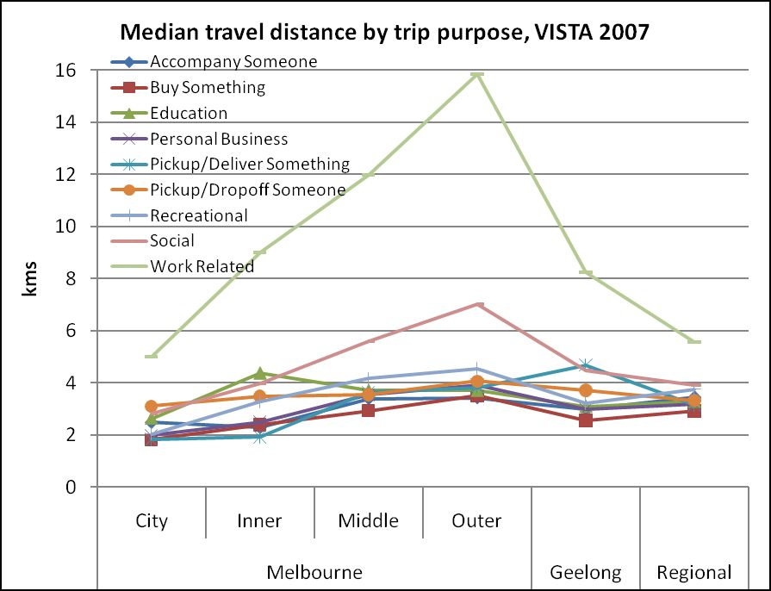

*Figure 1: Median Travel distance by trip purpose 2007*

In particular, it is not surprising that students have a higher level of active transport than the general population (as shown in *Figure 2*). Cycling represents 7.49% of journeys to education in inner Melbourne.

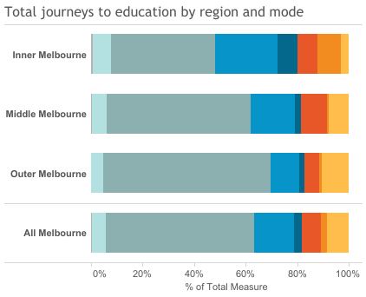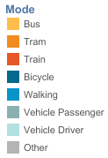

*Figure 2: Journey to Education Melbourne by mode and region VISTA 2013[1]*

*Figure 3: International Comparison*

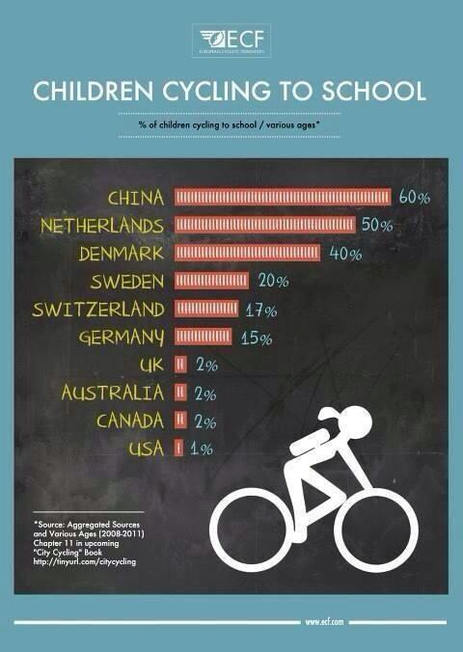

*Figure 4: Bike Parking at a high school in the Netherlands*

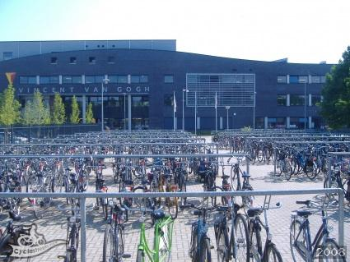

For all these reasons….

* It is essential to have safe infrastructure that means primary and secondary students can over time navigate their own way to and from school. This also builds independence and life skills which in turn builds confidence.
* It is important to ensure the short-stay drop-off car parking is not prioritised at the front gate of schools. This incentivises parents/caregivers to drive and drop, and robs children all any and all opportunity for active commuting before another day at the desk.
* Overwhelmingly it is still the female caregivers responsibility to do school pick-up / drop-off which has two aspects. It means that cycling commuting is more accessible to the male caregiver / father and also that it is the female / mother who is more likely to need to do multiple stops (trip chaining). Driving and parking is annoying and exhausting, as is getting kids in and out of cars, it also means that women are missing out on the benefits (physically and mentally) of walking and cycling. Ensuring that women and ‘mothers’ feel safe and confident cycling in their local community is an essential threshold in evaluating the efficacy of active transport infrastructure. Not just focussing on the suburb to city work commute.
* Increasing the number of students who walk and cycle also increases their visibility in our communities. This visibility helps ensure safer driver behaviour because there is increased awareness of school commuting times beyond signage and reduced speeds at the school gate. It also facilitates greater spontaneous and incidental interaction which build trust and social capital. It is an important process which helps ensure young people are known and welcomed into, validated by and then respectful of their community. This is a much healthier process than being driven around and then released onto the world as anonymous teenagers without strong community ties.

|  |  |  |
| --- | --- | --- |
|  |  | |

Infographic: https://www.researchgate.net/publication/322330719_Women_and_Transport_in_Indian_Cities

# References

Basch, C. E. (2011). Physical activity and the achievement gap among urban minority youth. Journal of School Health, 81(10), 626-634.

Donnelly, J. E., Hillman, C. H., Castelli, D., Etnier, J. L., Lee, S., Tomporowski, P., ... & Szabo-Reed, A. N. (2016). Physical activity, fitness, cognitive function, and academic achievement in children: a systematic review. Medicine and science in sports and exercise, 48(6), 1197.

Kohl III, H. W., & Cook, H. D. (Eds.). (2013). Educating the student body: Taking physical activity and physical education to school.

Singh, A., Uijtdewilligen, L., Twisk, J. W., Van Mechelen, W., & Chinapaw, M. J. (2012). Physical activity and performance at school: a systematic review of the literature including a methodological quality assessment. Archives of pediatrics & adolescent medicine, 166(1), 49-55.

<https://thedailymile.co.uk/>

1. VISTA 2013 <https://public.tableau.com/profile/vista#!/vizhome/VISTA-JourneytoeducationAccess/JTE-methodoftravel>