Getting More People on Bikes:

What works and what doesn’t

# Who Cycles and why?

There are 4 types of cyclists (Figure 1)[1]



Figure 1: 4 types of cyclist

The characteristics of these types of cyclists are shown below:

* Strong and fearless: These are the people who will cycle regardless of roadway conditions. They are ‘cyclists;’ and undeterred by road conditions other people would find terrifying. These are usually middle-aged men and in Australia nearly all of the people who regularly cycle are in these category. So when people talk about “cyclists” in Australia they are talking about this tiny percentage of the population. A bit like saying all car drivers do doughnuts and drag racing as a tiny percentage of car drivers do that.
* Enthused and Confident: This group are prepared to tolerate sharing the road with motor vehicles to a small extent, but they greatly prefer separate or protected bicycle facilities.
* Interested but Concerned: This group is curious about cycling but their reservations about safety prevent them from cycling. They are aware of the need for people to lead more active lives. They like riding a bicycle, remembering back to their youth, and they would like to ride more, however, they are terrified to ride on fast, busy roads. They get nervous thinking about what would happen to them on a bicycle when a driver runs a red light, or cars passing too closely and too fast. There is no way any of these people would let their children ride on such rods. None of these people regularly ride bicycles, however, they would ride if they felt safer riding on protected bike and paths without any cars at all.
* No way no how: This group is currently not interested in cycling at all

Currently in Australia, it is nearly entirely the Strong and Fearless who cycle. Neither the Enthused and Confident nor the Interested but Concerned feel sufficiently safe to cycle in large numbers. We need to help these people get on bikes.

# What Works: Make is Safe

Bits of **paint** applied to the road do **NOT** make cycling safe. This will **NEVER** be enough to get people, and especially not let their kids, to cycle regularly. Comparing the safety features of bikes and cars shows just how ridiculous this approach is

Car safety features:

* Air bags, front, side, curtain
* Anti-lock brakes,
* high strength laminated glass,
* seat belts,
* stability control systems

Compare this with safety features for bicycles:

* Paint, and an Esky lid on their head

Figure 2: bike Safety features vs Car Safety

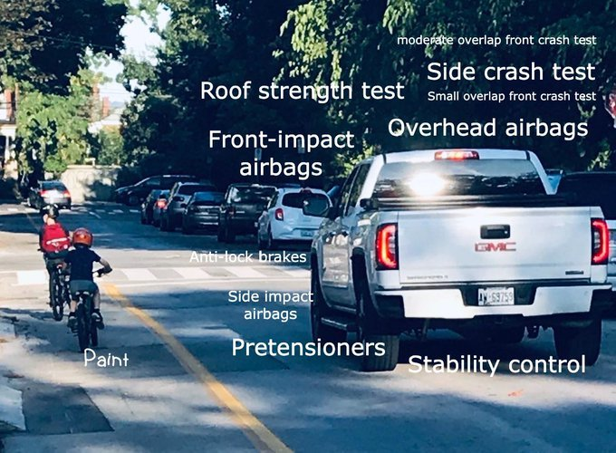

# Key Policies and Measures

There are the 7 policies and measures that have been proven around the world to get people on bikes[2]:

1. **Extensive systems of separate cycling facilities** 
   * Well-maintained, fully integrated paths, lanes and special bicycle streets in cities and surrounding regions
   * Fully coordinated system of colour-coded directional signs for bicyclists
   * Off-street short-cuts, such as mid-block connections and passages through dead-ends for cars
2. **Intersection modifications and priority traffic signals**
   * Advance green lights for cyclists at most intersections
   * Advanced cyclist waiting positions (ahead of cars) fed by special bike lanes facilitate safer and quicker crossings and turns
   * Cyclist short-cuts to make right-hand turns before intersections and exemption from red traffic signals at T-intersections, thus increasing cyclist speed and safety (translated into Australian, this would be a left hand turn, no crossing of traffic)
   * Bike paths turn into brightly coloured bike lanes when crossing intersections
   * Traffic signals are synchronised at cyclist speeds assuring consecutive green lights for cyclists (green wave)
   * Bollards with flashing lights along bike routes signal cyclists the right speed to reach the next intersection at a green light
3. **Traffic calming**
   * Traffic calming of all residential neighbourhoods via speed limit (30 km/hr) and physical infrastructure deterrents for cars
   * Bicycle streets, narrow roads where bikes have absolute priority over cars
   * ‘Home Zones’ with 7 km/hr speed limit, where cars must yield to pedestrians and cyclists using the road
4. **Bike parking**
   * Large supply of good bike parking throughout the city
   * Improved lighting and security of bike parking facilities often featuring guards, video-surveillance and priority parking for women
5. **Coordination with public transport**
   * Extensive bike parking at all metro, suburban and regional train stations
   * ‘Call a Bike’ programmes: bikes can be rented by cell phone at transit stops, paid for by the minute and left at any busy intersection in the city
   * Bike rentals at most train stations
   * Deluxe bike parking garages at some train stations, with video-surveillance, special lighting, music, repair services and bike rentals
6. **Traffic education and training**
   * Comprehensive cycling training courses for virtually all school children with test by traffic police
   * Special cycling training test tracks for children
   * Stringent training of motorists to respect pedestrians and cyclists and avoid hitting them
7. **Traffic laws**
   * Special legal protection for children and elderly cyclists
   * Motorists assumed by law to be responsible for almost all crashes with cyclists
   * Strict enforcement of cyclist rights by police and courts

# What works: Protected Bike Lanes! Nothing else

As has been shown around the world time and time and time again[3], the only thing that will get a significant number of people regularly cycling is a joined up network of protected bike lanes, not tokenistic efforts of paint randomly slapped down that suddenly ends in the middle of nowhere.

Figure 3: Comfortable infrastructure

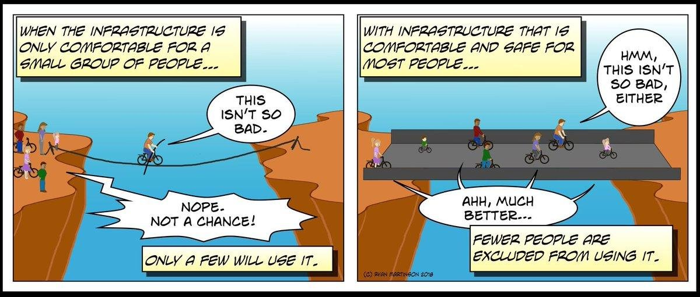

Figure 4: Cycling infrastructure Australian style (Qld)

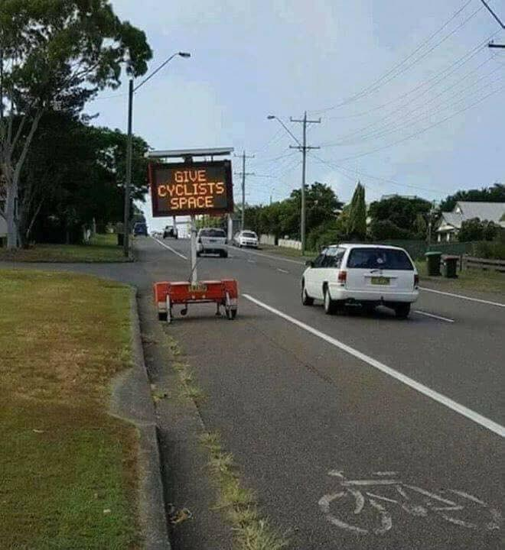

Figure 5 Cycling Infrastructure Australian Style 2 (Footscray)

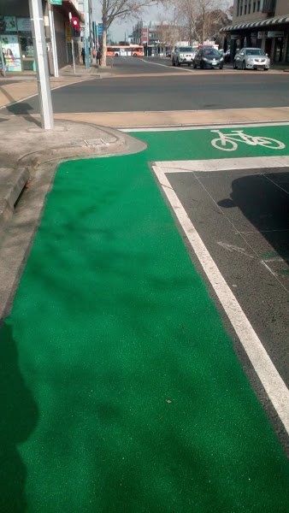

## Key Design Principles

There are nine key design principles that are vital and never completely followed by any authority in Australiia

1. Cyclists Separated from Volume Traffic
2. Cyclists Separated from Pedestrians
3. For the most part the “infrastructure” is separated from pedestrians
4. Cyclists must be treated as Vehicles, not Pedestrians
5. Routes Must Join Together
6. Routes Must Feel Direct
7. Routes Must Account for How People Behave  
   Purely Cosmetic Changes Should be Avoided
8. Barriers and Dismount Signs Should be Avoided
9. Routes Should be Designed by Cyclists

Figure 6: Key Design Principles

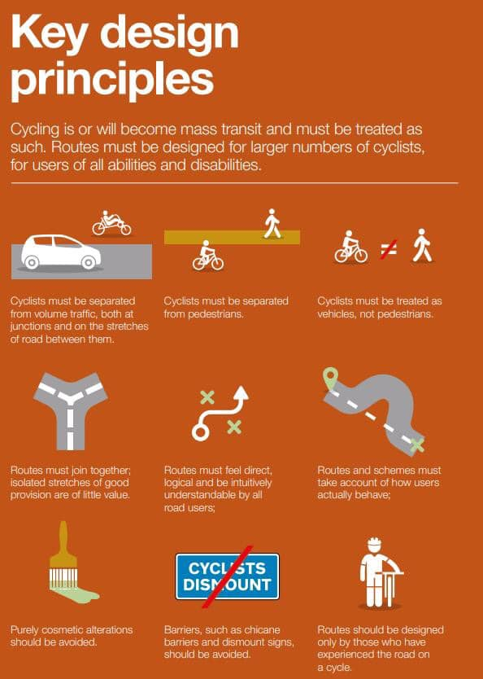

# World’s Best Practice: Not Clayton’s Best Practice

Sadly councils often use awful examples in other parts of Melbourne, such as Clayton, to justify terrible infrastructure. Why don’t we deserve the best?

## Seville, Spain

In a city of very few cyclists, the Spanish city of Seville planned and built a network of 50 miles of protected bike lanes in less than two years. It cost 5,000 parking spaces and $32 million but transformed the population of Seville, Spain. Today, 0.6 in ten trips in this former city of drivers is a bike ride. Cycling has grown 11x over in just four years. This is the story of how Seville became a cycling city.

<https://medium.com/vision-zero-cities-journal/how-seville-became-a-city-of-cyclists-fba864b4be66>

## Low Traffic Neighbourhoods London, UK.

Over the past decades, there has been a significant increase in traffic volumes on residential streets, resulting in greater noise, air pollution and road danger.

As a result, many local authorities have implemented modal filters (bollards or planters), through which people can walk or cycle, but not drive.

Many were implemented as early as the 1970s when increasing traffic was threatening the safety of children playing in the streets.

While a single filter used to be enough to remove through traffic from a residential area, nowadays satellite navigation apps like Google Maps and Waze simply direct people to the next cut-through, displacing the issue onto another street.

With more and more people using their phones instead of signs to get around, it’s increasingly common to see long queues of vehicles trying to negotiate narrow residential streets, or vehicles speeding through at night.

Some local authorities have therefore taken a more strategic, holistic approach which looks at removing through traffic from entire residential areas, keeping it on major roads.

This low-traffic neighbourhood (LTN) approach, widespread in the Netherlands, means private motorised vehicles can still access all homes and businesses, but they cannot cross through the neighbourhood.

People can therefore only travel through the area on foot, bicycle or bus

This approach has proven to significantly reduce traffic volumes not only on the residential streets but across the entire residential area.

This phenomenon is known as traffic evaporation, with short trips previously undertaken by cars being switched to other modes.

In a recent consultation, Hackney assumed a proposed low-traffic neighbourhood would result in 10% traffic evaporation, as a conservative estimate.

Low-traffic neighbourhoods have also shown to:

* increase physical activity through more walking and cycling
* benefit local businesses
* create new public space
* deliver improve air quality

In light of this, LTNs are best described as public health tools rather than transport tools

<https://www.sustrans.org.uk/for-professionals/infrastructure/an-introductory-guide-to-low-traffic-neighbourhood-design/>

## Auckland New Zealand

The way we get around our local streets has an effect on not only road safety, but on our fitness, health, and happiness. Places with higher rates of active travel and exercise are less likely to suffer from obesity and diabetes.

In 2012 in Māngere Central, people were driving a lot, even just to do short trips within their suburb. As well as this, people driving, walking, and cycling were more likely to be killed or hurt on the road than in other Auckland suburbs. People were being killed or seriously injured just doing normal things like going to the shops, to work, to school, to church, or visiting friends and whānau.

By changing the design of the streets, we hoped that people would feel more comfortable to walk and cycle to local destinations rather than drive. In doing so, this would improve road safety outcomes and help make people fitter, healthier, and more active.

The project is called Te Ara Mua – Future Streets meaning “the path ahead shaped by the path behind”.

<https://www.futurestreets.org.nz/>

1. Geller 2009 Four Types of Cyclists Portland Office of Transportation
2. Pucher, J., & Buehler, R. (2008). Making cycling irresistible: lessons from the Netherlands, Denmark and Germany. Transport reviews, 28(4), 495-528
3. Marshall, W. E., & Ferenchak, N. N. (2019). Why cities with high bicycling rates are safer for all road users. Journal of Transport & Health